Application Number | 07/2019/0069/FUL
Address | 62 Canberra Road  Leyland  Lancashire  PR25 3ER
Applicant | Mason Developments

Agent
Mr Peter Entwistle
40 Queensway Euxton
Chorley
PR7 6PW
United Kingdom

Development | Erection of single storey rear extension and new sloping roof over existing side extension (part retrospective)
Officer Recommendation  Officer Name | Approval with Conditions  Mr Chris Sowerby

Date application valid | 30.09.2019
Target Determination Date | 25.11.2019
Extension of Time | -

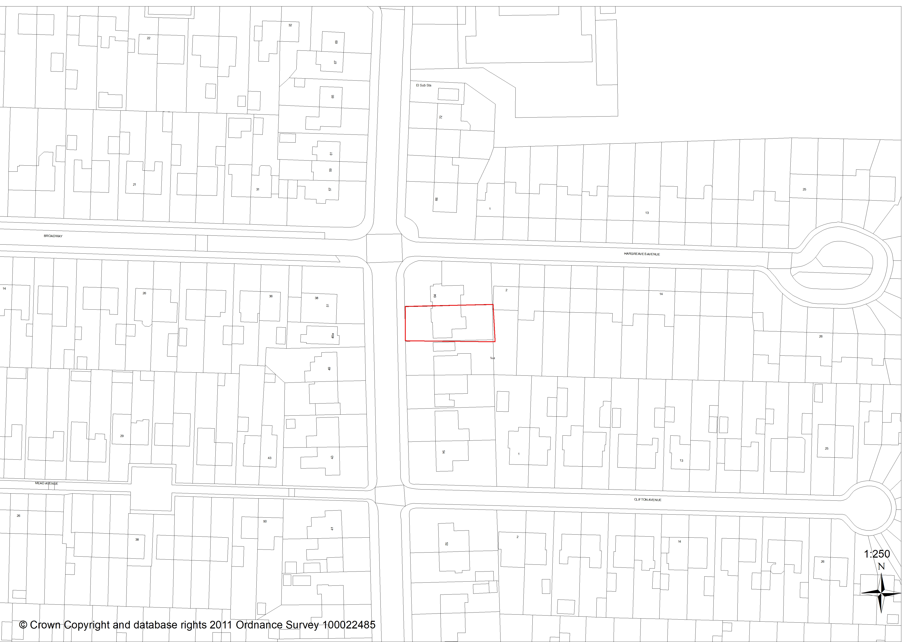

1. INTRODUCTION
1.1 A Ward Councillor has requested that the application be determined by the Planning Committee, taking into consideration the nature of the proposal the Director of Planning and Property has agreed to this request.

2. REPORT SUMMARY
2.1 The proposal, which is part retrospective, is for the erection of a single storey rear extension and a replacement mono-pitched roof over the existing single storey side extension to a vacant ground floor semi-detached commercial premise.

2.2 The application relates to a vacant ground floor semi-detached commercial premise (Class A1) fronting Canberra Road together with an existing single storey side element which formed a separate commercial premise. Whilst a convenience store is present on the opposite side of Canberra Road, the surrounding area is predominantly residential. The application site is within an area of land designated as Existing Built-Up Area under Policy B1 of the South Ribble Local Plan.

2.3 Amended plans have been submitted in order to remove references to the building being used as a restaurant with bar which the agent acknowledges would require planning permission for a change of use should the unit wish to be used for that purpose. The application is solely for an extension and alteration to a retail unit (Class A1).

2.4 The proposed alteration to the roof above the existing side element would be no higher than the existing parapet wall to the front which is to be removed. Roofs of a similar design and scale are on side extensions in the immediate locality. The proposed single storey rear extension would replace an existing and would only be partially visible from Hargreaves Avenue. The proposed extension is of a similar scale that is present on neighbour residential properties, including the immediate neighbouring property at 60 Canberra Road. The application also proposes the use of brickwork and tiles to match the existing property.

2.5 The proposed inter-relationships are acceptable and accord with the relevant minimum spatial separation standards.

2.6 County Highways acknowledge in their consultation response that whilst the parking level would not, and in fact currently does not, meet the parking standards detailed in Appendix 4 of the South Ribble Local Plan they raise no objections to the proposed development, highlighting that the proposed development would not have “severe impact on highway safety or capacity within the immediate vicinity of the site” (a ‘severe impact’ is the national policy requirement to substantiate a refusal on highway safety grounds). The floor area of the proposes extension, when viewed in isolation, would generate a need for 1 off-street parking space, with the proposal looking to increase the current off-street provision of 1 parking space to 4 off-street car parking spaces.

2.7 The proposed development is deemed to be in accord with Policies 1, 10 and 17 of the Core Strategy together with Policies B1 and G17 of the South Ribble Local Plan. The application is therefore recommended for approval subject to the imposition of conditions.

3. APPLICATION SITE AND SURROUNDING AREA

3.1 The application relates to a vacant ground floor semi-detached commercial premise fronting Canberra Road together with an existing single storey side element which formed a separate commercial premise. A residential flat is present on the first floor with the adjoining ground floor unit being currently occupied by a hair dressers.

3.2 The main premise most recently operated as a café with the business operating from within the side element (which was presumably originally an attached garage) being a beauty salon.

3.3 Whilst a convenience store is present on the opposite side of Canberra Road, the surrounding area is predominantly residential.

3.4 The application site is within an area of land designated as Existing Built-Up Area under Policy B1 of the South Ribble Local Plan.

4. SITE HISTORY

4.1 In 2000 a planning application (07/2000/0552) for a two-storey side extension and a single storey rear extension was withdrawn prior to determination.

4.2 In 2014 a Prior Notification application (07/2014/0176/TPD) was approved (i.e. prior approval not required) permitted a flexible change of from a shop (Class A1) to a café (Class A3). Under the terms of the Town and Country Planning Act (General Permitted Development) Order 2013 this temporary permitted use ceased on the 23 April 2017 with the lawful use of premise reverting back to Class A1.

5. PROPOSAL

5.1 Planning permission is sought, part retrospectively, for the erection of a single storey rear extension and a replacement mono-pitched roof over the existing single storey side extension.

5.2 The proposed single storey rear extension measures 3.2m (depth) x 6.6m (width) x 2.4-3.5m (height) with a mono-pitched roof and would replace a modest single storey outrigger on the rear elevation of the premise. The proposed extension is identified as being as a staff/store room for the premise. Two windows are proposed on the rear elevation of the proposed extension together with an external side door.

5.3 The proposed mono-pitched roof over the existing single storey side element would measures 2.5-3.5m height and would replace an existing roof up to 3m in height which is set behind a parapet wall.

5.4 All materials are to match that of the existing property, where appropriate.

5.5 Amended plans have been submitted in order to remove references to the building being used as a restaurant with bar which the agent acknowledges would require planning permission for a change of use. The application is solely for an extension and alteration to a retail unit.

6. REPRESENTATIONS

9 letters of objection have been received in relation to the proposal. A summary of the points raised follows:

Policy Issues
- Proposal would be contrary to local plan policies which seek economic growth in town centres

Character
- Proposed extended property would be out of character with the surrounding area
- Commercial unit of this size would be out of keeping with the residential surroundings

Relationship To Neighbours
- Loss of privacy / overlooking
- Overdominance

Highway Issues
- Increase in traffic / highway safety
- Congestion
- Inadequate parking provision

Other Issues
- Noise and disturbance as a result of increased deliveries and more customers
- No details of waste storage
- Factual inaccuracies contained within the submission
- The applicant’s identity and ownership matters relating to the unit are not clear including leasehold matters
- Area is already well served for large retail convenience stores

7. CONSULTATION REPLIES

7.1 County Highways have raised no objections to the proposal commenting that the Lancashire County Councils five year data base for Personal Injury Accident (PIA) indicates that there has been 1 recorded incident within the vicinity of the site within the last 5 years. They have however advised that on investigation of the details recorded, the incident appears to be of a nature that would not be worsened by the proposed development.

7.2 In regards to parking, County Highways advise “Drawing No.’Mason-2-1’ indicates that 4 parking spaces would be provided to the front of the site with access from Canberra Road. The proposed level of parking is not in line with South Ribble Borough Councils parking standards. However LCC Highways is of the opinion that the under provision of parking spaces would not have a severe impact on highway safety or capacity within the immediate vicinity of the site”. Further comment is made that parking restrictions are in place to protect the junction adjacent to the site.

7.3 A condition is recommended to be imposed relating to works to be undertaken within the adopted highway as result of an extension to the existing dropped kerb potentially being required.

7.4 Environmental Health have submitted no observations.

8. MATERIAL CONSIDERATIONS

Policy Considerations

8.1 i) NPPF
8.1.1 The NPPF promotes a presumption in favour of sustainable development and supports sustainable economic development, stating “Planning policies and decisions should help create the conditions in which businesses can invest, expand and adapt. Significant weight should be placed on the need to support economic growth and productivity, taking into account both local business need and wider opportunities for development.” (para. 80)

8.1.2 ii) Core Strategy Policy Considerations
8.1.3 Policy 1 of the Core Strategy is entitled ‘Locating Growth’ and encourages the focussing of growth and investment in the Key Service Centres of Chorley and Leyland and the other main urban areas in South Ribble.

8.1.4 Policy 10 of the Core Strategy is entitled ‘Employment Premises and Sites’ and highlights the need to protect sites last used and allocated for employment for future employments use.

8.1.5 iii) South Ribble Local Plan
8.1.6 The site is within an area of land designated as B1: Existing Built-Up Areas. Policy B1 permits the re-use and redevelopment of land and buildings provided that:

- the development complies with the requirements for access parking and services, as set out
elsewhere in the Plan;
- is in keeping with the character and appearance of the area; and
- will not adversely affect the amenities of nearby residents.

8.1.7 This will be assessed in the following sections of this report.

8.2 Policy Issues
8.2.1 Neighbours have raised objection on the basis of the proposal being contrary to planning policies which seek economic growth in town centres, in specifically Core Strategy Policy 11: Retail and Town Centre Uses and Business Based Tourism.

8.2.2 Policy 11 of the Core Strategy, together with the justification of Policy E4: District Centres in the South Ribble Local Plan, confirm that such retail policies are designed to prevent an over-proliferation of non-retail uses in town and district centres and not as a measure to prevent the presence of retail uses outside of town and district centres. Furthermore, it is also important to consider that the retail use at this location already exists and is historic.

8.3 Character / Appearance
8.3.1 Policy 17 of the Core Strategy and Policy G17 of the Local Plan, sets out design criteria for new development and requires development to be well related to neighbouring buildings and the locality in terms of its size, scale and intensity (plot coverage). In consideration of the above, the local distinctiveness and character of the local area have been assessed. Whilst the adjoining premise is a hairdressers and the premises opposite is a convenience retail store, the surrounding area is however predominantly residential comprising largely of traditional and modern semi-detached dwellinghouses. The property subject to this application together with the adjoining premise, whilst both being in commercial uses, are of the scale and form as surrounding residential properties.

8.3.2 The proposed alteration to the roof above the existing side element would be no higher than the existing parapet wall to the front which is to be removed. Roofs of a similar design and scale are on side extensions in the immediate locality.

8.3.3 The proposed 3.2m (depth) x 6.6m (width) single storey rear extension would replace an existing 1.5m (depth) x 3.6m (width) outrigger and would only be partially visible from Hargreaves Avenue. The proposed extension is of a similar scale that is present on neighbour residential properties, including the immediate neighbouring property at 60 Canberra Road. The application also proposes the use of brickwork and tiles to match the existing property.

8.3.4 Neighbours have objected on the basis of a commercial unit of this size would be out of keeping with the residential surroundings. The size of the proposed extension is however relatively modest, some 13sq m more than the existing outrigger than is to be demolished, and is located on the rear of the property with minimal impact on the streetscene.

8.3.5 For the above reasons the proposed development is considered to comply with Core Strategy Policy 17 and Policy G17 of the South Ribble Local Plan.

8.4 Relationship To Neighbours
8.4.1 The proposed replacement roof on the existing side element would have an eaves height of 2.5m which is 0.1m lower than the existing and has a maximum height of 3.5m which is 0.5m higher than the existing roof but 0.3m lower than the parapet roof which is to be removed. The adjacent property at 60 Canberra Road has a detached running garage adjacent to the party boundary with the application side. This inter-relationship is considered to be acceptable and will not result in an undue impact on the amenity of the neighbouring property in terms of overshadowing / overdominance.

8.4.2 No windows are proposed on the southern side elevation of the proposed single storey rear extension. The adjoining commercial premise at 64 Canberra Road has no ground floor windows on the rear elevation. The proposed single storey rear extension would therefore not have an undue impact on this property in terms of overshadowing / overdominance and overlooking / loss of privacy.

8.4.3 The proposed single storey rear extension would project a similar distance to the single storey rear extension on the adjacent residential property at 60 Canberra Road with a distance of 9m between the two extensions. Whilst the existing single storey rear extension of 60 Canberra Road also has an external side door present with the boundary treatment comprising of a 2m high hedge. This inter-relationship is considered to be acceptable with the proposal not having an undue impact on this property in terms of overshadowing / overdominance and overlooking / loss of privacy.

8.4.4 A distance of 6.5m would be present from the rear elevation of the proposed rear extension to the two-storey blank gable of an extension on 2 Hargreaves Avenue. A 1.8m high timber fence is present along the rear boundary of the site. With two ground floor windows proposed on the rear elevation of the proposed extension this inter-relationship is not considered to have an undue impact on the amenities of the neighbouring property in terms of overshadowing / overdominance and overlooking / loss of privacy.

8.4.5 The proposed inter-relationships are acceptable and accord with the relevant minimum spatial separation standards.

8.5 Highway Issues
8.5.1 A submitted site layout plan details the area of hardstanding to the front of the shop to be used to provide a line of 4 off-street car parking spaces. This would require an existing dropped kerb onto Canberra Road to be extended in agreement with LCC Highways, the details of which can be secured by a suitably worded condition. County Highways acknowledge in their consultation response that even with the additional off-street car parking spaces shown on the submitted site layout plan the parking level would not meeting the parking standards detailed in Appendix 4 of the South Ribble Local Plan.

8.5.2 The current situation is however that the existing main premise and the premise in the single storey side element on the site have 1 off-street parking space between them. The proposed extension would add 18.9sq m of floorspace to the unit, which Appendix 4 of the South Ribble Local Plan confirms would attribute a requirement of 1 off-street car parking space for an A1 non-food retail use. The proposal would increase the current provision by 3 off-street car parking spaces. County Highways have also advised that they raise no objections to the proposed development, highlighting that the proposed development would not have “severe impact on highway safety or capacity within the immediate vicinity of the site” (a ‘severe impact’ is the national policy requirement to substantiate a refusal on highway safety grounds).

8.6 Other Issues
8.6.1 Neighbours have objected on the basis of a potential increase in noise and disturbance as a result of increased deliveries and more customers together with lack of waste storage details. The property however already benefits from an established and historic lawful commercial use within the A1 Use Class. Government guidance and the NPPF in relation to the use on planning conditions is clear in that conditions can only be imposed where they are directly relevant to the development to be permitted and reasonable in all other respects. With the application only being for a modest extension, resulting in a 13sq m increase in floor area, and the property already benefitting from a historical commercial lawful use, it would not be reasonable to impose conditions to control the wider planning unit when it is unlikely that the extension will materially impact on the overall use of the premise.

8.6.2 Alleged factual inaccuracies contained within the submission have been referred to by neighbours, specifically the existing parking situation, the ability to see the site from public vantage points, original references to the premise being proposed to be used as a restaurant, the number of future employees and use to be undertaken within the unit. The premise is currently vacant with the application being submitted by the owner. In such circumstances where the end user is currently speculative it is acknowledged that certain questions on the planning application form may not be answerable. The applicant is however clear on the matter of ownership and what is being applied for. In addition to signing the Certificate A declartion of ownership on the application form the applicant has separately confirmed that they have total ownership of the company which owns the premise.

8.6.3 Objectors have objected on the basis of the area already well served for large retail convenience stores. The application relates to the extension of an existing A1 Class unit which is not restricted solely to use as a convenience store and may be used for a multitude of purposes including retail shops, hairdressers and travel agents. Given the current lawful of the premise there is nothing currently to prevent the end user of the unit from being a retail convenience store.

8.7 CONCLUSION
8.7.1 The proposed erection of a single storey rear extension and a replacement mono-pitched roof over the existing single storey side extension on the commercial premise (Class A1) is considered to be acceptable. The proposed development is not considered to be out of character with the area and will not adversely affect the amenities of nearby residential properties. County Highways have advised that will be no significant highway safety implications as a result of the development. The proposed development is deemed to be in accord with Policies 1, 10 and 17 of the Core Strategy together with Policies B1 and G17 of the South Ribble Local Plan. The application is therefore recommended for approval subject to the imposition of conditions.

RECOMMENDATION:

Approval with Conditions.

RECOMMENDED CONDITIONS:

1. That the development must be begun not later than the expiration of three years beginning with the date of this permission.

REASON: Required to be imposed pursuant to section 91 of the Town and Country Planning Act 1990.

2. All external facing materials shall match in colour, form and texture to those on the existing building.

REASON: In the interests of the visual amenity of the area and so that the Local Planning Authority shall be satisfied as to the details in accordance with Policy 17 in the Central Lancashire Core Strategy and Policy G17 in the South Ribble Local Plan 2012-2026

3. The car parking spaces indicated on approved plan ref. 'Mason-2-1' shall remain free from development and be made available for the parking of vehicles at all times.

REASON: To ensure the provision and retention of adequate on-site parking in the interests of residential amenity and highway safety as required by Policy F1 and Policy G17 in the South Ribble Local Plan

4. No part of the development shall be occupied until all the highway works within the adopted highway have been constructed in accordance with a scheme that shall be submitted to and approved by the Local Planning Authority in consultation with the Highway Authority as part of an appropriate legal agreement, under the Highways Act 1980. Reasons: In order to satisfy the Local Planning Authority and Highway Authority that the final details of the highway scheme/works are acceptable.

REASON: In order to satisfy the Local Planning Authority and Highway Authority that the final details of the highway scheme/works are acceptable before work commences on site and to enable all traffic to enter and leave the premises in a safe manner without causing a hazard to other road users and to be in accordance with Policy G17 in the South Ribble Local Plan 2012-2026.

5. During the site preparation and construction of the development no machinery, plant or powered tools shall be operated outside the hours of 08:00 to 18:00 Monday to Friday 09:00 - 13:00 on Saturdays. No construction shall take place at anytime on Sundays or nationally recognised Bank Holidays.

Reason: To safeguard the amenities of neighbouring properties in accordance with Policy 17 of the Central Lancashire Core Strategy.

6. The development, hereby permitted, shall be carried out in accordance with the submitted approved plans 'Mason-1-1' and 'Mason-2-1'.

REASON: To ensure a satisfactory standard of development in accordance with Policy 17 in the Central Lancashire Core Strategy and Policy G17 of the South Ribble Local Plan.

RELEVANT POLICY

1 Locating Growth (Core Strategy Policy)

10 Employment Premises and Sites (Core Strategy Policy)

17 Design of New Buildings (Core Strategy Policy)

POLB1 Existing Built-Up Areas

POLG17 Design Criteria for New Development

Note:

1. The amended vehicular access, within the adopted highway will need to be constructed under a section 184 agreement of the 1980 Highways Act (Vehicle crossings over footways and verges), The Highway Authority hereby reserves the right to provide the highway works within the highway associated with this proposal. Provision of the highway works includes design, procurement of the work by contract and supervision of the works. The applicant is advised to contact LCC before works begin on site. Further information and advice can be found at www.lancashire.gov.uk and search for "vehicular crossings".

